My Visit to Bad Reichenhall,
Diary and Events Summary

Copied with many changes from “My diary of my travel to Bad Reichenhall”

Ze’ev Sharon (Kozakowski)
July 2013

Preview
We drove to Germany, Irith and I, after attending the four days march at Nijmegen, the Netherlands. We rented a car at Kleve in Germany and on Sunday morning we drove to to Bad Reichenhall, a distance of about 950 kilometers. We divided the trip over two days.
The purpose of the visit was: to visit the town where I was born in, to see it and try to get an impression from the camp where I was born in and of the views around. Feel the place. If possible I'd love to get some new information for my research.
Supplied with a Samsung II Tablet and a Smartphone I bought the very eve of the trip. On the tablet I have loaded my family photo album and photos taken by others in Bad Reichenhall. I presented the photographs on several meetings and the tablet served me very well for this purpose. In addition these two devices served me as a backup camera.

21st July 2013 Sunday
In the morning we left Joop’s house in Nijmegen and drove to Germany via Venlo. At about 19:00 we stopped at Gasthof Lamm in Weinstadt (80 euros), a beautiful town. We showered and went down to dine: schnitzel in capers sauce, I had a beer, and Irith local white wine. We shared a cake for dessert (45 euros). We walked a little in the peaceful atmosphere of the small town. In the church square opposite the Gasthof stands a monument to the soldiers of the town who were killed during WWI. I did not photograph because it was already dark. We fell dead tired into bed.

22ed July 2013 Monday
Departure in the morning to Bad Reichenhall and a meeting with Dr. Lang, city archive.

At 1415 we arrived to the parking lot of City Archives- StadtArchiv of Bad Reichenhall.
We were greeted by Dr. Johannes Lang, a young man (about 40 + in my opinion), a vigorous and sporty person. He says that there are no materials that could interest me in the city archives, which means there are no documents about the DP Camp and the Jews who lived there.
If there are materials from the camp they are, he says, archived in Munich Stadt Archiv. About a year ago he wrote that most of the documentations from the DP Camp may be in the U.S. and Israel for the reason that the camp was run by U.S. authorities and Israel-related organizations.
Johannes, he said I could call him by his first name, brought The Album known to me from Mickey Mottola, son of Genia who was a nurse in the camp. Johannes has a twin Album which looks in better condition. He said that a man approached him and asked if he had any interest in the album. “I said that I do and bought it for 100 Euros," he said with a smile.

Dr. Lang told me all he knows about The DP Camp. Much of the information I already have known from my own research. It looked to me that his interest in the DP Camp is relatively new. Yes, he said, he is interested in information on the DP Camp and would love to get pictures that I have from the camp. Well, I promised to send him some.
The military camp was built, he said, by the Nazis on 1934/35. In 1946 the Nazi camp became a DP Camp for Jewish refugees.
There were two Nazi military camps on the site. One of infantry mountain fighters (GebirgsjagerBrigade), whose insignia was the Edelwise flower and the other camp was an artillery camp. The two camps are now combined into one camp of the mountain fighters’ brigade.

Johannes said that at the main gate of the camp was a drawing of two Nazi soldiers and a stone statue of an eagle and the swastika at the bottom. On my visit at the camp on the next day I saw that by the main gate there is a drawing of soldiers but it looked a different one, I would say "a softer" one. The Eagle statue still exists but without the swastika.
Johannes showed me in his book, on page 800, a photograph of the camp gate. The photo shows three pictures of Ze'ev Jabotinsky hanging by the gate. Perhaps there was some event related to the Revisionist Party at the camp when this photo was taken.
In "Mottola's photo album" there is a clear picture of the camp gate in a snowy winter day. The eagle statue is with no swastika. A large sign hangs above with the word “Tikvah” in Hebrew letters. "Hope."

On August 4th, I sent to Johannes an email trying to understand how the camp looked like those days. On august 5th he replied: At the time the Infantry Brigade camp was converted to a DP camp, the Artilery camp was held by the U.S. Army for several years.
The DP Camp entrance was the gate of the infantry brigade, the same main gate of today. This is the one which is decorated with a painting of soldiers and stone eagle.

Johannes told me that there was a hospital in the camp. No, he does not know it’s location. There was a police in the camp. Also a school. I told him that there was a number of schools including ORT school. I told him about ORT school in Neustadt where Mom and Dad learned in. There are two pictures of ORT "fachshulhe” in Bad Reichenhall DP Camp in the so called “Motola Album”.

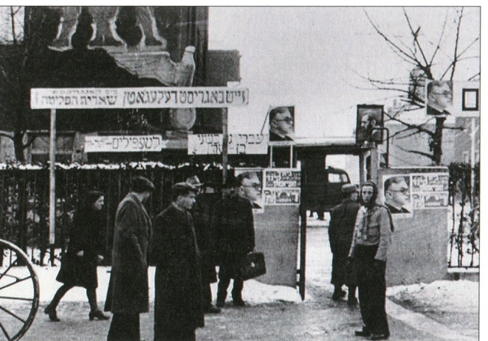
1. Camp gate in Dr. Lang's book

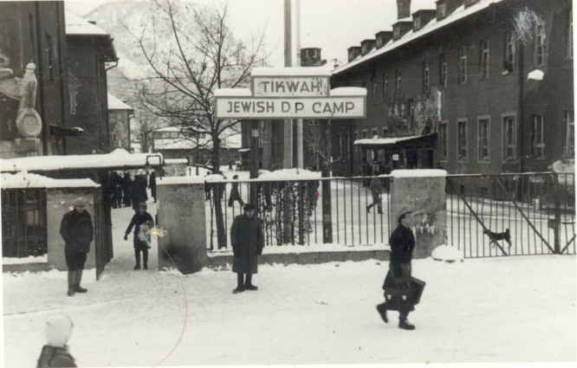
2. Camp gate in "Mottola" Album

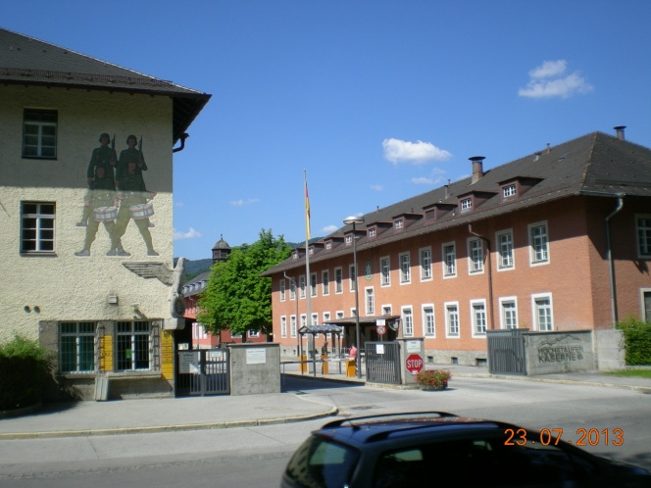
3. A recent photograph of the camp gate

Dr. Johannes Lang’s Book:
During the meeting Johannes browsed through his thick and reach with information book. The book tells the history of Bad Reichenhall, and includes information on the DP camp.
Book’s title: Geschichte von Bad Reichenhall. Published in 2009, ISBN 978-3-87707-759-7.
In the Pedestrian Zone at the town’s centre I bought a copy of the book. (58 euros). A thick book which contains a lot.

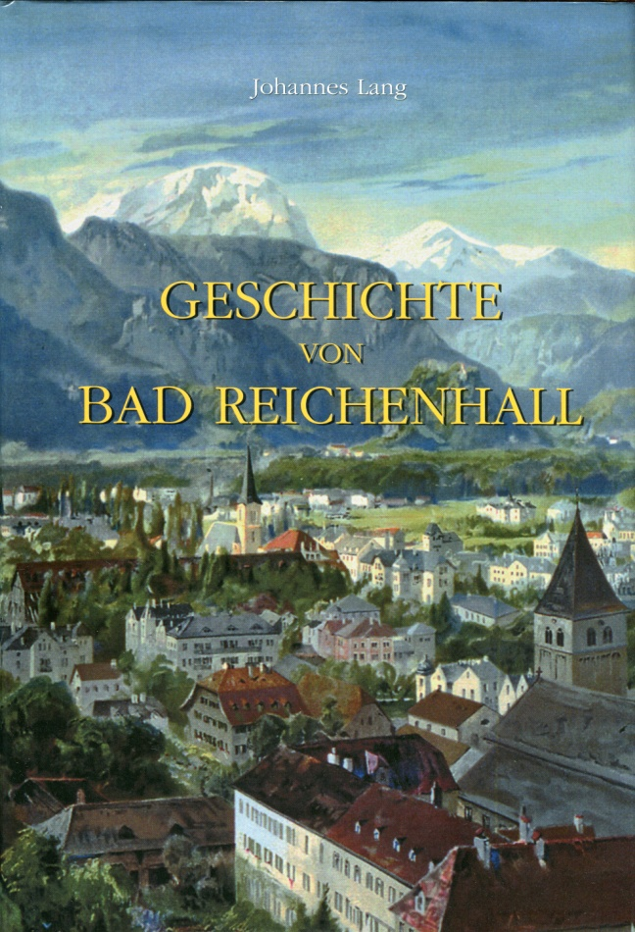
4. A photo of the book cover

23ed July 2013 Tuesday
Today we visit the military camp which was DP Camp.

Yesterday at the meeting I told Johannes that I would like to visit the camp and he arranged a meeting with the commander of the camp, a friend of his. Johannes told us that tomorrow morning we would arrive at the camp gate at 09:30 and ask for the commander who will pick us up! I was very glad.
After breakfast at Erika Hotel we drove by our rented car about 10 minutes to the army camp near the city at NonnerStr. Just across the river.
By the Information at the main gate of the camp, we announced our arrival. A thin and blond young soldier came and drove us to the base commander in his Mercedes car. He showed us to the office of the Colonel, commander of the camp.
His title as prescribed yesterday by Johannes:
Stellertretender Brigadekommandeur
Oberstbentuant (or Oberstleutnant. comment by Samy S. 20.9.2013).
Name of the Brigade (copied from the sign at the gate) is, in a free translation: mountain hunters Brigade 23: Gebirgsjagerbrigade 23.

When we took pictures the commander said that his rank is full Colonel. He is a nice, welcoming person. You hardly see him as a figure of a mountain warrior as one might expect him to be.
We talked in his office. The colonel told us about an Israeli delegation which held a ceremony at the camp gate. They placed a sign telling about the time that there was a DP camp of Jews who survived the Holocaust. He opened a thick binder and leafed through it until he found correspondence relating to the event. My predecessor, he said, was a very organized in terms of bureaucracy and kept all correspondence. To my wonderment I have seen in the folder letters carrying Hebrew titles of the municipality of Haifa! It turns out that the initiative for the event came from artists from Haifa and Bad Reichenhall. A photographer artist from Haifa, Armand Beraru and an artist from Bad Reichenhall started the process. Another person involved was Moshe Pearlman, a painter and sculptor from Haifa. He was in Bad Reichenhall, participating in an exhibition and joined the ceremony. Moshe, as a two years old baby, was in Bad Reichenhall in 1948 with his parents on their way from Russia to Israel.
The colonel says that the ceremony took place about 4 years ago and that among the participants were people from Israel, the mayor of Bad Reichenhall, Johannes Lang, the Colonel and others.
After we returned to Israel Armand Beraru told me that the ceremony was attended by 49 Jews, most of them where casual visitors in Bad Reichenhall, and are not related to the camp.
(see photos about the ceremony in http://www.alemannia-judaica.de/bad_reichenhall_juedgeschichte.htm
scroll down to the bottimn)

Translation of the memorial sign (by using Google Translate):
In memory of the thousands of Jews
Who survived the Holocaust
From 1945 to July 31, 1951
In the Barracks of Bad Reichenhall
They found a temporary home
Until they could immigrate to Israel as free people.
Bad Reichenhall, Gebirgsjager Brigade 23

The colonel says that they do not hide what happened here and that they transfer the history of the site to their soldiers. They indicate that there was here a Jewish DP camp and they made it into a legacy of their brigade.
He told us about the "Reds" who wanted to remove the drawings of the soldiers and the eagle statue from the main gate. Dr. Lang’s opinion, said the colonel, was that if the painting will be painted white it would not do any good. It is much better to leave the original painting be. It will remind everyone of the past. History must not be hidden.

The colonel said a number of times the word "Tikvah" in Hebrew correct accent. I explained him the meaning of the word: Hope. Apparently he already knew the meaning of “Tikvah”. This was the hope to return to Israel, he said.

We went downstairs. Right next to the building was entrance gate to the DP camp. Here was the artillery camp. An old cannon is placed here as a monument. But, by now I know that the main entrance was at the other gate.

I opened my tablet and showed him a photo taken in the fifties. He said that it was taken right where we are! The windows of the building on the right in the photograph are the headquarters today, the mountain in the background is, he said after inspecting the mount and the photo, exactly the mountain in front of us. In the photo there is a buildings at the left side. He said that they have been removed and replaced by a parking lot. He took few pictures just as he understood that the picture was taken then.

The colonel gave us all the necessary time without any signs of impatience and let me take all pictures I wanted, though this is a military camp. He instructed his assistant soldier to take us everywhere we want and take pictures as far as we like. The soldier suggested that I’ll take pictures of the huge stables. They use mules, he explained, to carry equipment. I photographed. Mainly because I remembered that my mother told me that they lived in a large barak which used to be a stable for horses. It could be that she and my father may have lived right here.

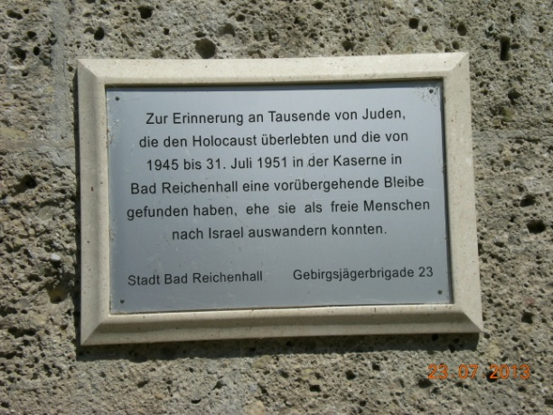
5. Memorial plaque at the gate of the Artillery Camp

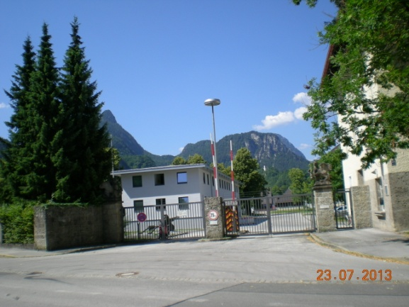
6. View of the Artillery Camp Gate

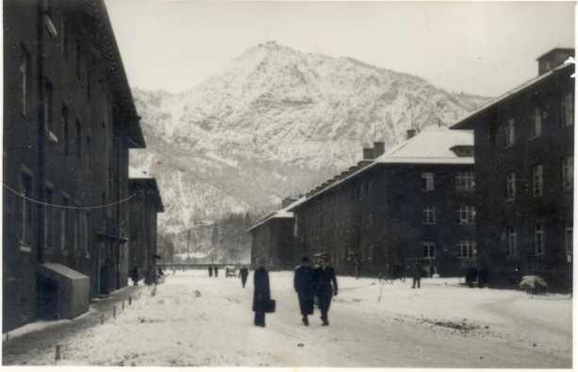
7. The photo which was taken here in the 40’s

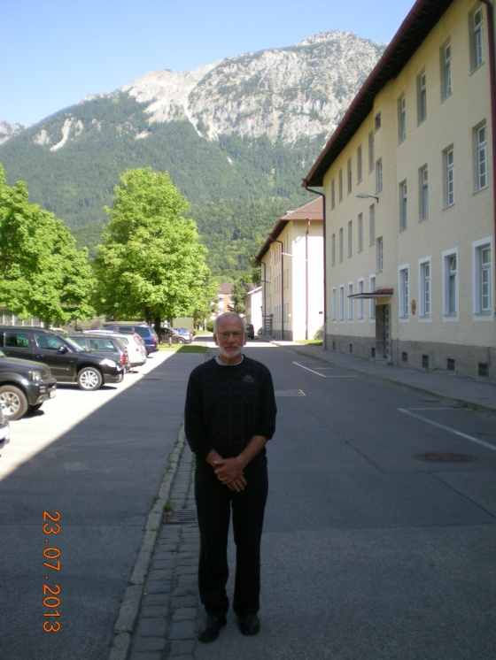
8. My photograph of the same place

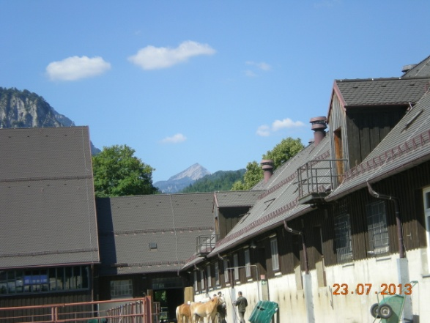
9. The Stables

We returned, full of impressions, to rest in the shade of trees in the hotel garden.
At noon we went to the cable car right next to the camp. Every half hour a car goes up and down to Predigtstuhl. 8 minutes ride up to 1614 meters.
In the restaurant at the top we ordered sausages with potatoes and Sauer Kraut with white horseradish and mustard and beer. For dessert we had Apple Strudel with Zenf.
We returned by cable car. The view down below looks like a map. You can clearly see the city, the Salzach River and lake and the military camp.

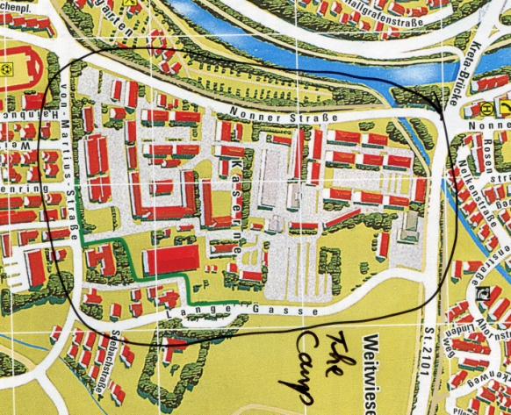
10. the camp in City map

24th July 2013 Wednesday
We walked to the Alt Stadt. It is very close to the city archive where we met Johannes a day before yesterday. We had coffee and cake in the bakery at the entrance. The ancient city was built very close to the mountain and its walled remnants are still there.
Back in town Irith attended a concert at KurMusik. There was a classical music concert with works by Verdi, Dvorak and others performed by the Philharmonic of Bad Reichenhall. I went to the beer garden (BierGarten) where we were last night. I had Zwickl Beir and schnitzel with Kartofl salad served with jam. And another jar of Normal Bier.

The Cemetery of St. Zeno
According to Johannes, Jews who died during their stay in the camp were buried in the general cemetery (Christian) adjacent St. Zenu Church.
I went to the cemetery which is located a few hundred meters from our hotel, on SalzburgStr.
I scanned the area for over an hour and did not find any graves of Jews. There were hardly any tombs of the years 1945-51. Most of the tombstones were from 1999 on. When I finished my search a strong but short rain fell.
In a conversation with Johannes he explained that the practice here is that a person is buried for ten years and if there is no one to continue paying for the land - another person can be buried in the same place.
The next day we met with Reinhard Kastner, director of tourism information office in Bayerisch Gmain. Among other things we talked about where were buried the Jews who died in the camp. He said they were buried in St. Zeno. When I told him about the results of my visit in the cemetery he said that the graves were likely destroyed. As far as he knows after 10 years, another person may be buried in the same plot, unless someone pays the fee.
Reinhard suggested another option to look for Jewish graves. In the little cemetery adjacent to the military camp. I thought it was a good idea because the place is very near to the camp. Reinhard showed me the place on the map. This Cemetery is adjacent to Nonner Kirchel (church). Yet, he was there about 4 weeks ago and saw only graves of Germans who live nearby.
On Friday I discussed the same topic with Thomas Maltan. He also says that people of the DP Camp were buried in the General Cemetery of St. Zeno. He repeated the explanation that the burial is for a period of 10 years. After this time a fee has to be paid for an additional period of 10 years. If someone does not pay for the land it can be purchased by another and someone else can buried there. The original tomb stone will be destroyed.

On Friday I went again to St. Zeno Church, this time with the Irith. The church is close as 400 meters from our hotel. It is a big church and some different from other churches we visited. At the altar there is a children drawings of Africa motives. Strange. There is a model of a gray donkey on wheels. Secluded corner with a drawing which shows a soldier with a gun. A model of the Temple with the Ark and the Menorah. The model consists of three parts with Jesus on the left one. If you put a nickel in the slot the light goes on. I donated 1 Euro to the church and the light came on. For a while.

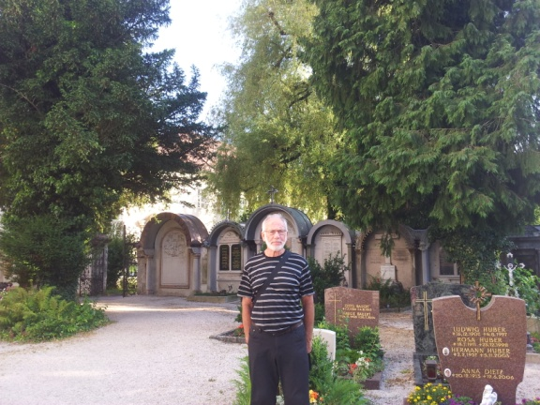
11. St. Zeno Cemetery

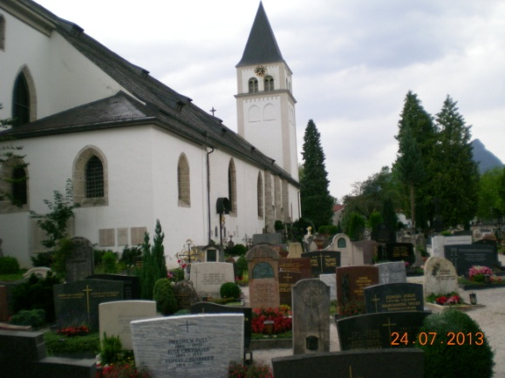
12. Church St. Zeno

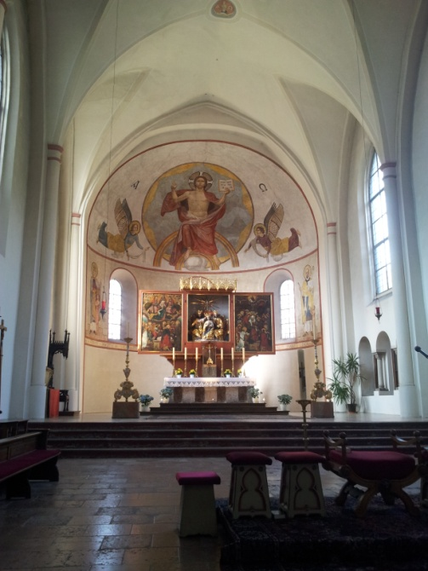
13. Interior of the church

25th July 2013 Thursday
We drove to Lake Konigssee. Parking lots are packed with lots of cars. The weather is quite hot. Many Bavaria souvenir shops, many blocks of salt and other stones. I had coffee and cheesecake, not too exciting, both.
We went down to the lake. It is a beautiful long and narrow lake, surrounded by forested mountains. We took a boat cruise to St. Bortolomeo (St. Bartholoma), which is about a half length of the lake. A guide wearing a white shirt and explained in German and produced laughter from the passengers. He stopped the boat, took out a trumpet, and played a short piece. Echo returned the whole tune. And again. He explained to the passengers that it is his colleague who plays back ...
We reached the old church which has a special structure. A few months ago Micky Mottola sent me a photograph of the church with a request to identify the location. It was Dr. Lang who found the location. Now I filmed and photographed the place in life.

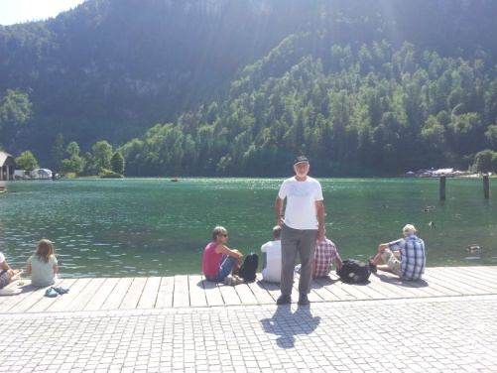
14. Lake Konigsee

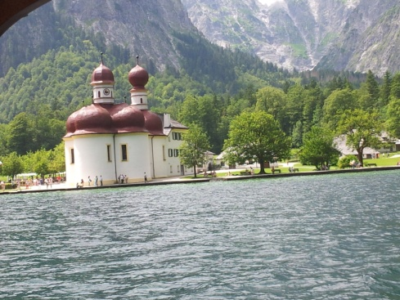
15. Church of St. Bartolomeo

We drove with our rented Mecedes to Bayerisch Gmain where we have some tasks: to visit the cemetery in hope to find the graves of Jews who died in the Bad Reichenhall DP camp; meet with Reinhard Kastner who is the tourist information manager and take pictures at the site were most likely our family took a picture in the fifties.

I entered the tourist information office which is located right on the main road, with my smartphone open on a mail from Reinhard Kastner. The man was there, even though it was near closing time, after 4 pm. He immediately recognized me from the email I sent him. He was very friendly and enthusiastic and interested. We talked a lot, he listened with interest and contributed from his knowledge. At one point, he closed the door and we continued our conversation inside the office. He said that it is very interesting to meet people with life stories from the DP camp.

Reinhard said that in Bayerisch Gmain was kind of children's camp, probably an orphanage for Jewish children. It was in a building which was earlier a hotel. Once a woman came from the U.S. or Canada, and inquired about the place, in which she once was as a child.

I showed Reinhard my pictures on the tablet and he was really interested. I showed the picture where mom, dad, Alter, Ann, Sonya and her mother are sitting on wooden fence. Reinhard recognized immediately the location. He pulled out a map and marked the exact spot where the photographer stood. The building on the left of the picture is the Guest House still existing today, he said. The building on the right also exists today!
The place is only several hundred meters from the tourist information office and, so he says, is about a mile from the camp. It is very likely that they came there by foot. The photographer was standing on the road which in those days was not at all crowded. Today, he said, the road is busy and he thinks I could not take pictures there. After we ate we went back and took pictures.

Reinhard recommended we go to eat near the Church of Grosgmain which is in Austria, a distance of 500 meters. At Hotel Votterl. We did.

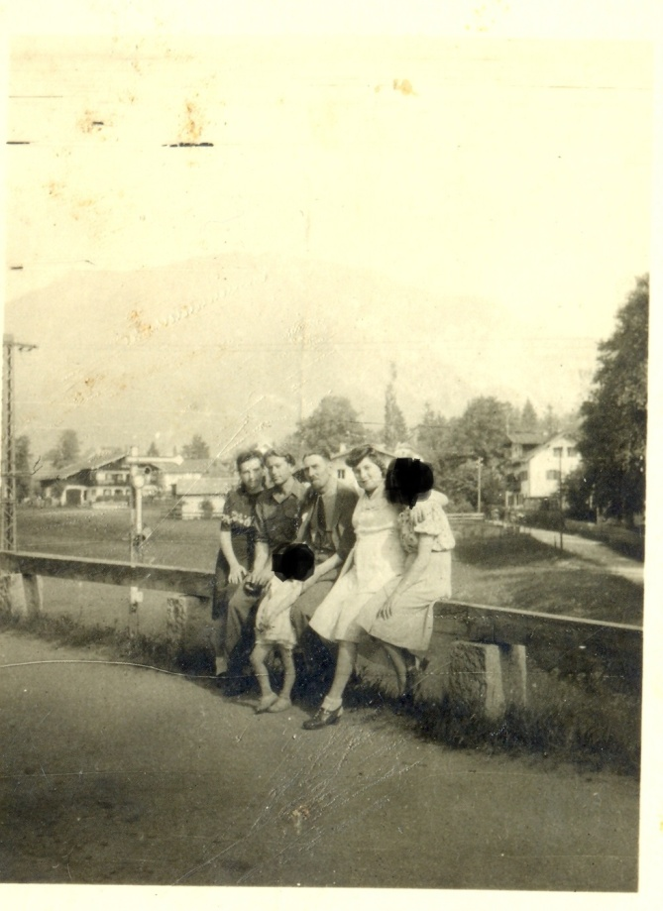
16. Old photograph taken at Bayerisch Gmain

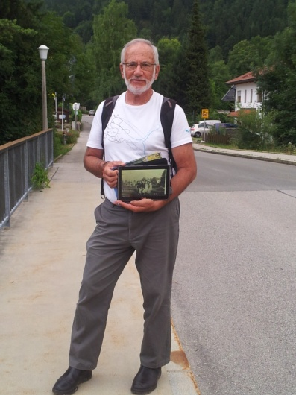
17. I with tablet in hand
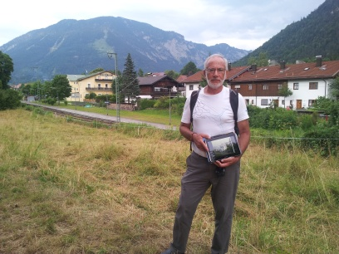
18. Photo taken at about the same place where the picture was taken in the fifties.

26th July 2013 Friday
I went to the municipality, on the recommendation of Reinhard, to Standesamt. Irith went to the beautiful pedestrian street of Bad Reichenhall.
At the City Hall plaza was nice market mainly of of food: vegetables, fruits, cheese, sausages, smoked fish.

At the entrance to the new building (it did not look new to me) was a colorful and happy bunch of people dressed in Bavarian folk costumes. They are probably people who sign up a wedding in the Rathouse. I photographed.
Ground floor, room No. 2 – I saw on the sign at the entrance a familiar name: Maltan Thomas. He is the person I corresponded with about a visit in Bad Reichenhall 10 years ago, in 1993. I introduced myself and the relationship we had. Maltan asked when I was born. I said: 1948 and he reached his hand and pulled out a thick book from a shelf. I was born in November, I replied, and immediately he browsed through the pages and soon found my Birth Certificate. The book is written by a fountain pen. It took some effort to read through the hand written documents, also perhaps of the old German language and probably because of Jewish names that were inconvenient to him to read.
For 10 Euros I got an official copy of the certificate.
It turns out that this office deals with Birth and Marriage records. Maltan said these events which were held in the DP Camp were also recorded in the municipality!
(*) in a letter he sent to me years ago Maltan wrote that not all records of the camp are archived.

I asked for the birth certificate of Raphael K. Rafi was born too in Bad Reichenhall in 1948. His parents were friends of my parents, from the introduction in the camp.
Maltan searched in another book, an ABC index and found the certificate of Raphael K. No, he said, you cannot have a copy of the certificate. Only the person himself can ask for it. It can be done by email: thomas.maltan @ stadt-bad-reichnhall.de

The same goes for Marriage Records. He said that anyone who got married in the DP Camp will appear in the municipality records. I was sure that marriage were only registered in the camp, as they were most likely, traditional Jewish events…

My Birth Certificate:
Registry was on November 19, 1948. It looks as though the information has been sent from the camp hospital to the Standsamt. Interesting.
Date of birth is November 11, 1948 and time of birth 17:45. Maltan says birth time may have a deviation error of about 45 minutes, if I understood correctly.
My name in the certificate is Zisko. My mother’s name: Ruth Lowenstein. He says there is no father name which means that my mother was not married ... ( I know that my parent had at this time false surnames, Lowenstein and Lewenthal, instead of their true surname Kozakowski).
Date of birth of "Ruth" is: January 18, 1927 in Grodno, Poland.
Place of birth: IRO Lager.
I actually have a similar birth certificate, printed, which was most likely produced in the camp.
From the birth certificate here I learned the time of birth my birth.

Death Records, said Maltan, are also kept in the municipality. The office who deals with them is in the old Rathouse and the person in charge is Franz Schmidt. You can contact him via email: franz.schmid @ stadt-bad-reichenhall.de

We went to Kurgarten for a coffee and cake. On a stage in the garden the Big Band Orchestra from Lebendorf was preparing for a concert. Precisely at 7:30 pm they started to play. Beautiful melodies. The singer, on the other hand, was pretty bad. He plays much better his brass. We spoke with a couple who came from a neighboring town specifically to hear the Big Band. The man was interested in my family story. After the concert we went to the BierGarten for beer and dinner.

27th July 2013 Saturday
Today we leave Bad Reichenhall. On the route we will visit Chiemsee Lake and the castle of Ludwig the 2nd. There I hope to find a statue by which Rachell was photographed when she was about three years old.

We drove to Prien on the banks of the lake. A drive of about 160 km. at 1 pm we sailed to the main island, Herren Chiemsee. It’s a sail of about 15-20 minutes on quiet water. The sun was extremely hot and we sat under the roof inside the ship. Most Germans actually like to sit in the sun and be fried.
At the entrance to the island you have to buy a ticket, 10 Euros per person for a guided tour to the palace and several other museums on the island. Irith took a horse and cart (3 Euros). I walked on the summer path. At the entrance to the big palace there are two pools. At the center of each is a big sculpture and many sculptures are placed around each pool. If you look backwards you see the lake.
I saw a statue of three children angels just like the statue by which Rachell was photographed next to when she was 3 years or so old!

I approached three guides who were waiting at the entrance to the palace for their groups. I showed them the photo on my tablet. One blonde nice looking woman said that these statues are replicas. The origins are kept in Spain, and thus the image can be taken here or elsewhere.

Another guide, older, said that the picture was taken exactly here! Look at the statue with a horse head in the background of your photo, he said. The third guide, a young man, said that he is the English language guide of my tour in the palace. He was interested in the picture and the story behind it.
Look, he said, you see grass in the picture whereas today there is a pool. The pool was built in the 90s and when the photo was taken there was grass around the statues.

Interesting, I was thinking, how people from Bad Reichenhall came here to the Palace of Ludwig the Second. The distance is about 60 km and then they had to take a ship to the island. Yet, they did come.

The guide, Lukas is his name, did a beautiful and professionally guided tour of the palace. Ludwig II built the palace out of admiration to Louis 14th King of France. Ludwig admired his personality and the way he ruled – with no rules and out a divine order.
Ludwig II never used the palace and in fact he had no intention to complete it as whole, only the outer shell and the luxurious rooms copied from Palace Versailles. The splendid gardens are also a copy of the Palace of Versailles.
There are enormous chandeliers in the Palace. Every evening a team of 40 lit 15,000 candles.
Construction of the palace came out to the cost of the two other palaces built by Ludwig II, combined. The budget was out before completing the job.

I took photos of the statue of three angels by which Rachell was photographed about 64 years ago.
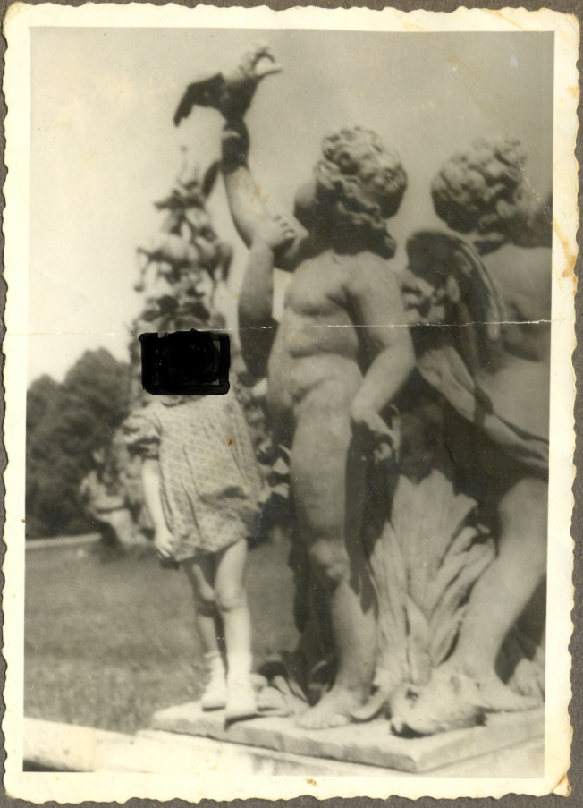
19. Rachell and the statue

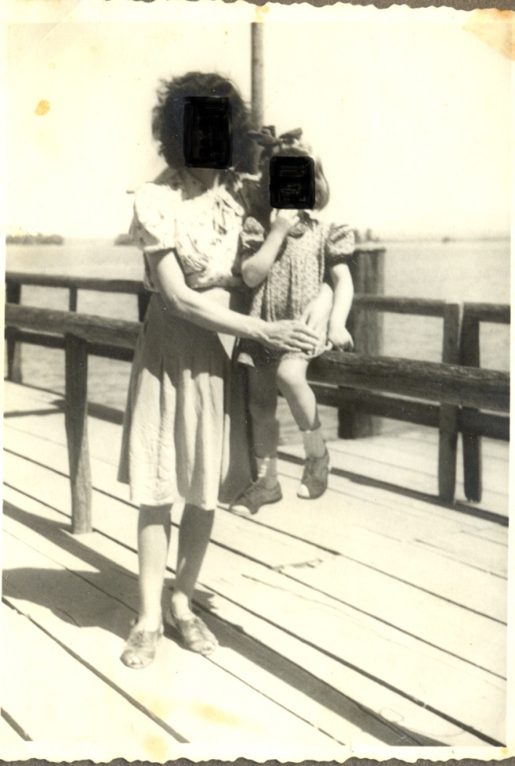
20. Rachell and her mother apparently on the pier

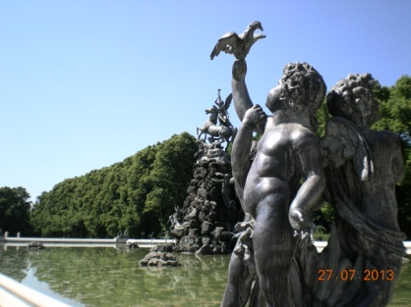
21. Statue of three angels
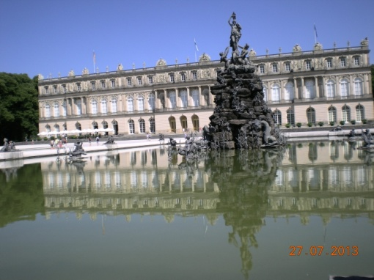
22. View of the Palace
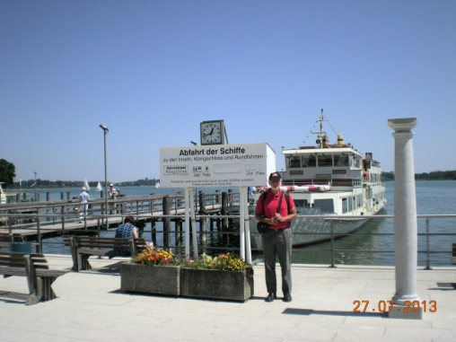
23. Ze’ev at the pier

28th July 2013 Sunday
Today we fly back home from Munich Air-Port.

Two additional pictures (their story is not included in the Diary):
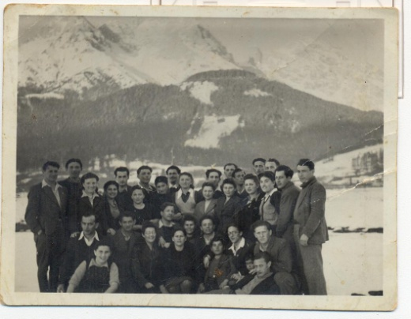
24. Members of “Kibutz Yad Shmuel”
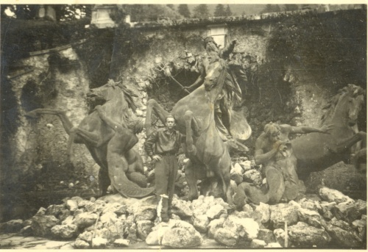
25. Eliezer Kozakowski, my dad, with the statue at Linderhof

